SAVEETHA INSTITUTE OF MEDICAL AND TECHNICAL SCIENCES
Department of Electronics and Communication Engineering

Software Engineering — CO1 / AT-2
Agile Sprint Planning & User Story Workshop
Project: Intelligent AI-Based Airport Baggage Tracking and Management System

Submitted by: RR Thiyagesh(192572007)

1. Project Vision and Stakeholders

1.1 Project Vision
To design and deliver an AI-powered, RFID-enabled baggage tracking and management platform that gives passengers, airlines, and airport operations real-time visibility into baggage movement, predicts and prevents delays using artificial intelligence, and automates passenger communication — thereby reducing baggage mishandling, lowering operational costs, and improving overall passenger satisfaction.

1.2 Project Objectives
- Track baggage in real time from check-in to baggage claim using RFID and IoT sensors.
- Optimize baggage routing across sorting, transfer, and loading points.
- Predict baggage delays using AI models trained on historical and live data.
- Notify passengers automatically at key milestones of their baggage journey.
- Reduce baggage misrouting through automated exception detection and alerts.
- Generate operational analytics and reports for airline and airport management.
- Improve overall airport logistics and turnaround efficiency.
- Enhance passenger satisfaction and trust in baggage handling services.

1.3 Key Stakeholders
Stakeholder | Role / Interest
Passengers | Primary end users who check in baggage and track it through the app; expect transparency and timely notifications.
Airline Ground Staff / Baggage Handlers | Scan RFID tags at checkpoints, load/unload baggage, and act on misrouting alerts.
Airport Operations Manager | Monitors the live dashboard, oversees sorting efficiency and turnaround performance.
Airline Customer Service Team | Uses scan history and search-status tools to resolve passenger complaints about missing or delayed bags.
Sorting Facility Operators | Execute AI-recommended routing decisions at the sorting hub.
IT / Systems Administrators | Maintain the cloud platform, RFID middleware, and data pipelines.
Airport Security / Customs | Require baggage traceability for compliance and screening purposes.
Product Owner | Represents airline/airport business interests; owns and prioritizes the product backlog.
Scrum Master | Facilitates Agile ceremonies and removes impediments for the development team.
Development Team | Cross-functional team of software, IoT, and AI/ML engineers building the platform.
Aviation Regulatory Bodies (e.g., IATA) | Define baggage handling and data-traceability standards the platform must comply with.

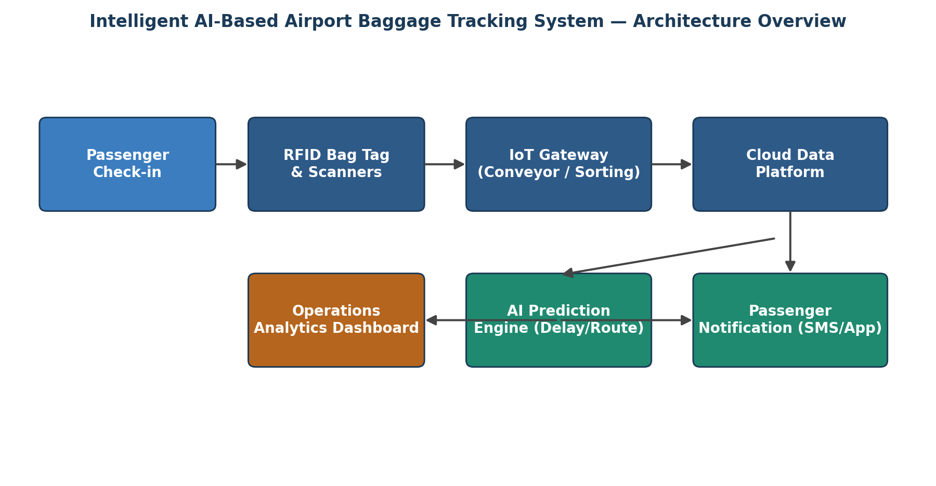
Figure 1: High-level system architecture connecting passengers, RFID/IoT infrastructure, cloud platform, and AI services.
2. Epics and User Stories
The product requirements are decomposed into five Epics, each broken down into detailed user stories following the standard Agile format: "As a <user>, I want <feature>, so that <benefit>."

Epic 1: Real-Time Baggage Tracking
US1: As a passenger, I want to view the real-time location of my checked baggage on the airline app, so that I know where it is throughout my journey.
US2: As a baggage handler, I want to scan RFID tags at each checkpoint, so that the system automatically logs baggage movement.
US3: As an operations manager, I want a live dashboard of all baggage currently in transit, so that I can monitor overall handling efficiency.
US4: As a system administrator, I want RFID scan data to sync to the cloud in near real time, so that tracking information is never stale.

Epic 2: AI-Based Delay Prediction & Routing Optimization
US5: As an operations manager, I want the system to predict potential baggage delays before they occur, so that I can take corrective action proactively.
US6: As a sorting facility operator, I want the system to recommend optimal routing paths for baggage, so that transfer times are minimized.
US7: As a data analyst, I want the AI model to learn from historical baggage-flow data, so that predictions improve over time.

Epic 3: Passenger Notification System
US8: As a passenger, I want to receive a notification when my bag is loaded onto the aircraft, so that I have peace of mind.
US9: As a passenger, I want to be notified immediately if my baggage is delayed or misrouted, so that I can plan accordingly.
US10: As a passenger, I want to receive a notification when my bag reaches the baggage claim carousel, so that I know when to head there.

Epic 4: Operational Analytics & Reporting
US11: As an operations manager, I want to generate daily/weekly baggage-handling reports, so that I can evaluate performance and identify bottlenecks.
US12: As an airline manager, I want analytics on baggage mishandling rates by route/flight, so that I can address recurring issues at specific stations.

Epic 5: Baggage Misrouting Reduction & Exception Handling
US13: As a baggage handler, I want an alert if a bag is scanned at the wrong sorting point, so that I can immediately correct the routing.
US14: As a passenger, I want to report a missing bag through the app and receive a live search status, so that I feel supported during resolution.
US15: As a customer service agent, I want access to the full RFID scan history of a bag, so that I can quickly investigate misrouting complaints.

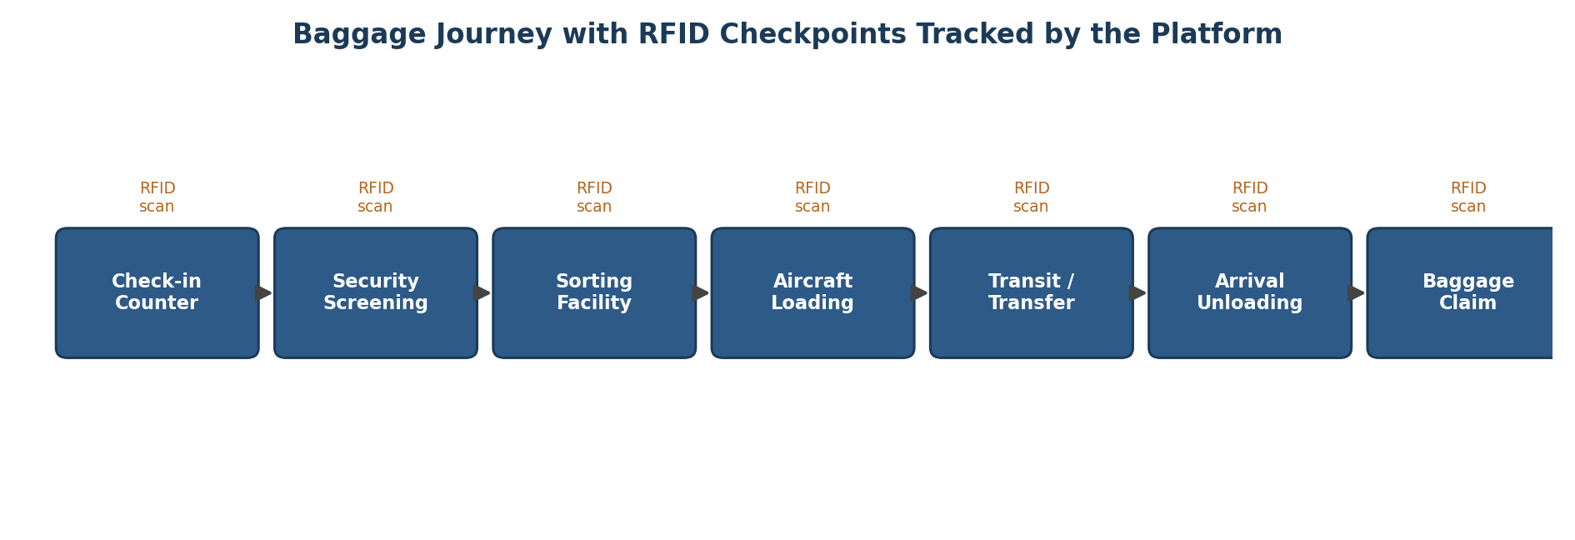
Figure 2: Baggage journey with RFID checkpoints tracked end-to-end by the platform.

3. Acceptance Criteria (Given–When–Then)
Acceptance criteria for the user stories selected into Sprint 1 are defined below using the Given–When–Then format to ensure they are specific, measurable, and testable.
US2 — As a baggage handler, I want to scan RFID tags at each checkpoint, so that the system automatically logs baggage movement.
Scenario 1: Successful checkpoint scan
Given a baggage tag with a valid RFID identifier reaches a checkpoint scanner, When the handler scans the tag, Then the system logs the checkpoint, timestamp, and bag ID within 5 seconds.
Scenario 2: Invalid or unreadable tag
Given an RFID tag is damaged or unreadable, When a scan is attempted, Then the system flags the bag for manual verification and notifies the handler.
US4 — As a system administrator, I want RFID scan data to sync to the cloud in near real time, so that tracking information is never stale.
Scenario 1: Normal connectivity
Given the checkpoint device has an active network connection, When a scan event is generated, Then it is synced to the cloud database within 3 seconds.
Scenario 2: Temporary network loss
Given the network connection is temporarily unavailable, When scan events occur offline, Then events are buffered locally and synced automatically once connectivity is restored.
US1 — As a passenger, I want to view the real-time location of my checked baggage on the airline app, so that I know where it is throughout my journey.
Scenario 1: Baggage in transit
Given a passenger has a checked-in bag with an active RFID tag, When they open the tracking screen in the app, Then the app displays the bag's most recent checkpoint and status.
US3 — As an operations manager, I want a live dashboard of all baggage currently in transit, so that I can monitor overall handling efficiency.
Scenario 1: Dashboard refresh
Given multiple bags are being processed across checkpoints, When the operations manager opens the dashboard, Then the view auto-refreshes every 10 seconds showing current bag counts per checkpoint.
US8 — As a passenger, I want to receive a notification when my bag is loaded onto the aircraft, so that I have peace of mind.
Scenario 1: Loading confirmed
Given a bag's RFID tag is scanned at the aircraft-loading checkpoint, When the loading event is confirmed, Then the passenger receives an app/SMS notification within 1 minute.
US10 — As a passenger, I want to receive a notification when my bag reaches the baggage claim carousel, so that I know when to head there.
Scenario 1: Arrival at claim
Given a bag's RFID tag is scanned at the baggage-claim checkpoint, When the arrival event is confirmed, Then the passenger receives a notification including the carousel number.
US13 — As a baggage handler, I want an alert if a bag is scanned at the wrong sorting point, so that I can immediately correct the routing.
Scenario 1: Route mismatch detected
Given a bag's expected route does not match the sorting point it was scanned at, When the scan event is processed, Then an alert is sent to the handler's console immediately with the correct routing instruction.
4. Product Backlog Prioritization
The product backlog below lists all 15 user stories ranked by priority, using MoSCoW prioritization combined with business value and dependency analysis. Foundational tracking capabilities (Epic 1) are ranked highest because AI prediction (Epic 2) and analytics (Epic 4) depend on the data they generate.
Rank | User Story | MoSCoW Priority | Business Value | Story Points
1 | US2: As a baggage handler, I want to scan RFID tags at each checkpoint, so that the system automatically logs baggage movement. | Must Have | High | 8
2 | US4: As a system administrator, I want RFID scan data to sync to the cloud in near real time, so that tracking information is never stale. | Must Have | High | 5
3 | US1: As a passenger, I want to view the real-time location of my checked baggage on the airline app, so that I know where it is throughout my journey. | Must Have | High | 5
4 | US3: As an operations manager, I want a live dashboard of all baggage currently in transit, so that I can monitor overall handling efficiency. | Must Have | High | 8
5 | US8: As a passenger, I want to receive a notification when my bag is loaded onto the aircraft, so that I have peace of mind. | Should Have | Medium | 3
6 | US10: As a passenger, I want to receive a notification when my bag reaches the baggage claim carousel, so that I know when to head there. | Should Have | Medium | 3
7 | US13: As a baggage handler, I want an alert if a bag is scanned at the wrong sorting point, so that I can immediately correct the routing. | Must Have | High | 5
8 | US9: As a passenger, I want to be notified immediately if my baggage is delayed or misrouted, so that I can plan accordingly. | Should Have | Medium | 5
9 | US5: As an operations manager, I want the system to predict potential baggage delays before they occur, so that I can take corrective action proactively. | Should Have | High | 13
10 | US6: As a sorting facility operator, I want the system to recommend optimal routing paths for baggage, so that transfer times are minimised. | Should Have | High | 13
11 | US7: As a data analyst, I want the AI model to learn from historical baggage-flow data, so that predictions improve over time. | Could Have | Medium | 8
12 | US14: As a passenger, I want to report a missing bag through the app and receive a live search status, so that I feel supported during resolution. | Should Have | Medium | 8
13 | US15: As a customer service agent, I want access to the full RFID scan history of a bag, so that I can quickly investigate misrouting complaints. | Could Have | Medium | 3
14 | US11: As an operations manager, I want to generate daily/weekly baggage-handling reports, so that I can evaluate performance and identify bottlenecks. | Could Have | Medium | 5
15 | US12: As an airline manager, I want analytics on baggage mishandling rates by route/flight, so that I can address recurring issues at specific stations. | Could Have | Low | 8

Prioritization rationale: Real-time tracking and notifications form the data foundation the rest of the platform depends on, so they are scheduled first. AI-driven prediction and routing (Epic 2) require historical scan data to train on, so they are prioritized after the tracking foundation is in place. Analytics and reporting (Epic 4) are lower priority as they consume, rather than produce, operational data.
5. Sprint Backlog Planning (Sprint 1)
The seven highest-priority user stories from the product backlog are selected for Sprint 1 (a 2-week sprint) and broken down into actionable development tasks below.
User Story | Development Tasks | Owner | Est. Hours
US2 (8 pts) | - Design RFID tag data schema and checkpoint identifiers  - Implement RFID reader integration middleware (API layer)  - Develop checkpoint scan-event logging service  - Unit test scan-event capture at 4 simulated checkpoints | Backend Team | 32 hrs
US4 (5 pts) | - Set up cloud message queue for scan events  - Build real-time sync service (edge device to cloud DB)  - Implement retry/offline buffering for network drops | Backend/DevOps | 20 hrs
US1 (5 pts) | - Design passenger-facing tracking UI (mobile/app screen)  - Integrate tracking API with app front end  - Display current checkpoint status with timestamps | Frontend Team | 18 hrs
US3 (8 pts) | - Design operations dashboard wireframe  - Implement live baggage map/table view (staff console)  - Add filters by flight number and checkpoint  - Load-test dashboard with simulated bag volumes | Frontend/Ops | 30 hrs
US8 (3 pts) | - Define loading-event trigger condition  - Integrate SMS/app push notification service | Integration Team | 10 hrs
US10 (3 pts) | - Define baggage-claim arrival trigger condition  - Send push/SMS notification with carousel number | Integration Team | 10 hrs
US13 (5 pts) | - Define expected-route validation rules per flight  - Implement mismatch-detection logic at scan time  - Trigger real-time alert to handler console | Backend Team | 18 hrs

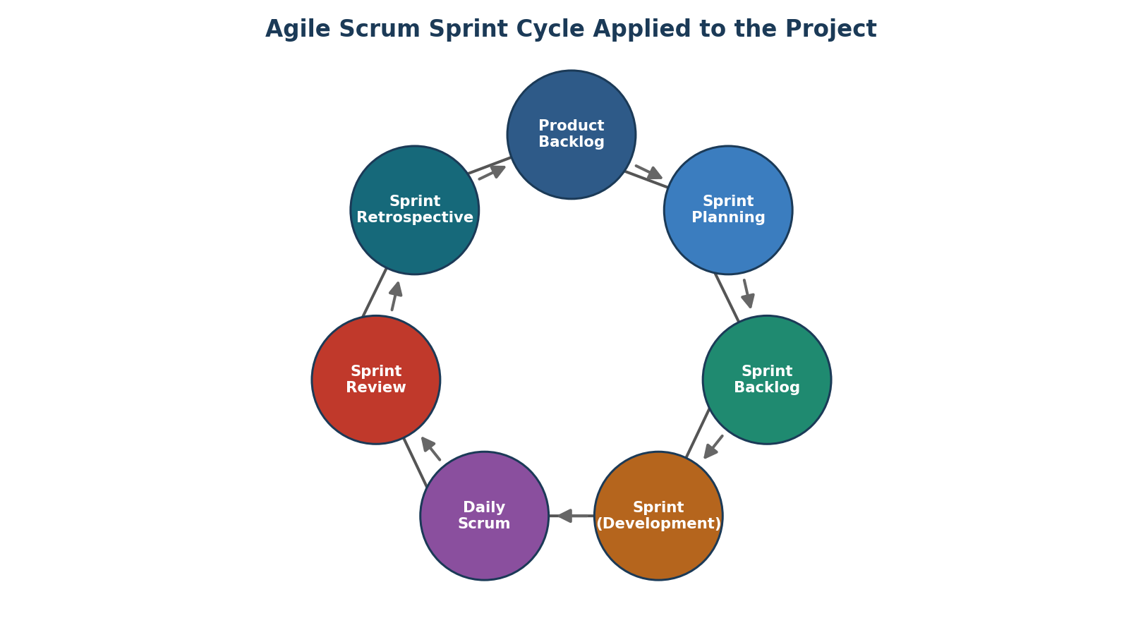
Figure 3: Agile Scrum cycle followed for planning, executing, and reviewing Sprint 1.
6. Story Point Estimation
Story points were estimated using Planning Poker with the Fibonacci sequence (1, 2, 3, 5, 8, 13, 21). Each team member estimated independently; the final value reflects team consensus after discussing outliers. Estimates account for complexity, effort, and uncertainty rather than raw time.
Story | Estimation Basis | Points (Fibonacci) | Justification
US2 | RFID scanner + middleware integration across hardware and software; multiple checkpoint types. | 8 | High technical integration effort; hardware dependency; unknowns in reader compatibility.
US4 | Cloud sync service with offline buffering and retry logic. | 5 | Well-understood messaging pattern; moderate complexity from reliability requirements.
US1 | Passenger-facing UI consuming an existing tracking API. | 5 | Mostly front-end work; some complexity in real-time UI refresh.
US3 | Live operations dashboard with filtering across large data volume. | 8 | UI plus performance tuning for real-time refresh at scale.
US8 | Single event-based notification trigger. | 3 | Simple, well-defined trigger and message template.
US10 | Single event-based notification trigger with carousel lookup. | 3 | Similar to US8; minor extra lookup logic.
US13 | Rule-based route mismatch detection and alerting. | 5 | Requires validation-rule design per flight, moderate logic complexity.
US9 | Delay/misroute detection depends on AI prediction output. | 5 | Dependent on Epic 2 outputs; moderate integration risk.
US5 | AI/ML delay-prediction model design, training, and validation. | 13 | High complexity; data science effort, model tuning, and unknowns in accuracy.
US6 | Optimization algorithm for baggage routing across constraints. | 13 | Complex combinatorial optimization; significant design and testing effort.
US7 | Historical data pipeline for continuous model learning. | 8 | Data engineering effort; moderate complexity in pipeline automation.
US14 | Missing-bag reporting flow with live search-status updates. | 8 | Multiple integration points (app, ops team, search status).
US15 | Read-only scan-history lookup and display. | 3 | Simple query and display feature.
US11 | Scheduled reporting service (daily/weekly). | 5 | Standard reporting logic; moderate effort in report design.
US12 | Analytics on mishandling rate by route/flight. | 8 | Requires aggregation across multiple data dimensions and visualization.

Sprint 1 total effort: 8 + 5 + 5 + 8 + 3 + 3 + 5 = 37 story points. Assuming a 6-member cross-functional team with an established average velocity of 35–40 points per 2-week sprint, this load is realistic and slightly conservative, leaving buffer for RFID hardware-integration risk.
7. Sprint Goal and Expected Deliverables

7.1 Sprint Goal
By the end of Sprint 1, deliver a functioning RFID-based real-time baggage tracking core — from check-in to baggage claim — including a passenger-facing tracking view, a live operations dashboard, cloud-synced scan data, automated milestone notifications, and basic misrouting alerts, establishing the data foundation required for AI-based delay prediction and routing optimization in later sprints.

7.2 Expected Sprint Deliverables
- Functional RFID scanning integration deployed and tested at four checkpoints (check-in, sorting, loading, claim).
- Real-time baggage location view integrated into the passenger-facing airline app.
- Live operations dashboard for airport/airline staff showing baggage-in-transit status.
- Cloud-synced baggage event database with offline buffering for network interruptions.
- Automated app/SMS notifications for baggage-loading and baggage-claim-arrival events.
- Rule-based misrouting alert for bags scanned at an incorrect sorting point.
- Sprint demo to stakeholders and a sprint retrospective report documenting lessons learned.

7.3 Definition of Done
- All selected user stories meet their acceptance criteria and pass QA testing.
- Code is peer-reviewed, merged, and deployed to the staging environment.
- RFID scan events are verified end-to-end across all four checkpoints.
- Notifications are verified on at least two device platforms (iOS and Android).
- Sprint review conducted with the Product Owner and key stakeholders for sign-off.

